Here’s what I put together for the R code with the data given by Christian.

-Jason

#STAT 201

#Group Final Project

#Christian Price, Joseph Lyon, Jason Biesinger, Jesse Van Horn, Jon Wilson, Rex Henretta

#Fall 2015

#Data

knocking=read.table(header=TRUE,text="

Run AirFuelRatio OctaneLevel AmountOfKnock

1 Lean Booster1 30

2 Rich Booster2 58

3 Stoichiometric Regular 82

4 Lean Regular 75

5 Stoichiometric Booster1 70

6 Lean Booster1 30

7 Lean Booster2 55

8 Stoichiometric Booster2 75

9 Rich Booster1 46

10 Lean Regular 72

11 Rich Regular 61

12 Rich Regular 64

13 Stoichiometric Booster2 76

14 Lean Booster2 58

15 Rich Booster1 43

16 Stoichiometric Regular 85

17 Stoichiometric Booster1 70

18 Rich Booster2 57

")

#fit the model

out.knocking=aov(AmountOfKnock~AirFuelRatio+OctaneLevel+AirFuelRatio:OctaneLevel,data=knocking)

#Inference

anova(out.knocking)

#95% Conf Interval

TukeyHSD(out.knocking)

#Mean by factor

by(knocking$AmountOfKnock,knocking$AirFuelRatio,mean)

by(knocking$AmountOfKnock,knocking$OctaneLevel,mean)

#Standard Deviation by factor

by(knocking$AmountOfKnock,knocking$AirFuelRatio,sd)

by(knocking$AmountOfKnock,knocking$OctaneLevel,sd)

#Best plot for Air/Fuel Ratio

main.effect<-c(53.33333,54.83333,76.33333) # from by(knocking$AmountOfKnock,knocking$AirFuelRatio,mean)

se<-sqrt( 993.50 / 2) # Mean Sq Residuals / number of replicates

mp<-barplot(main.effect,names=c("Lean","Rich","Stoichiometric"),

col=c("blue","green","black"),

ylab="Amount of Knock",xlab="Air / Fuel Ratio",

ylim=c(0,100))

arrows(mp,main.effect-se,mp,main.effect+se,

code=3,angle=90,col="gray")

#Best plot for Octane Level

main.effect<-c(73.16667,48.16667,63.16667) #from by(knocking$AmountOfKnock,knocking$OctaneLevel,mean)

se<-sqrt( 950.00 / 2) # Mean Sq Residuals / number of replicates

mp<-barplot(main.effect,names=c("Regular","Booster #1","Booster #2"),

col=c("red","brown","yellow"),

ylab="Amount of Knocking",xlab="Octane Level",

ylim=c(0,100))

arrows(mp,main.effect-se,mp,main.effect+se,

code=3,angle=90,col="gray")

#QQ plot

qqnorm(resid(out.knocking))

resid(out.knocking)

#Interaction

interaction.plot(knocking$AirFuelRatio,knocking$OctaneLevel,knocking$AmountOfKnock,type='b')

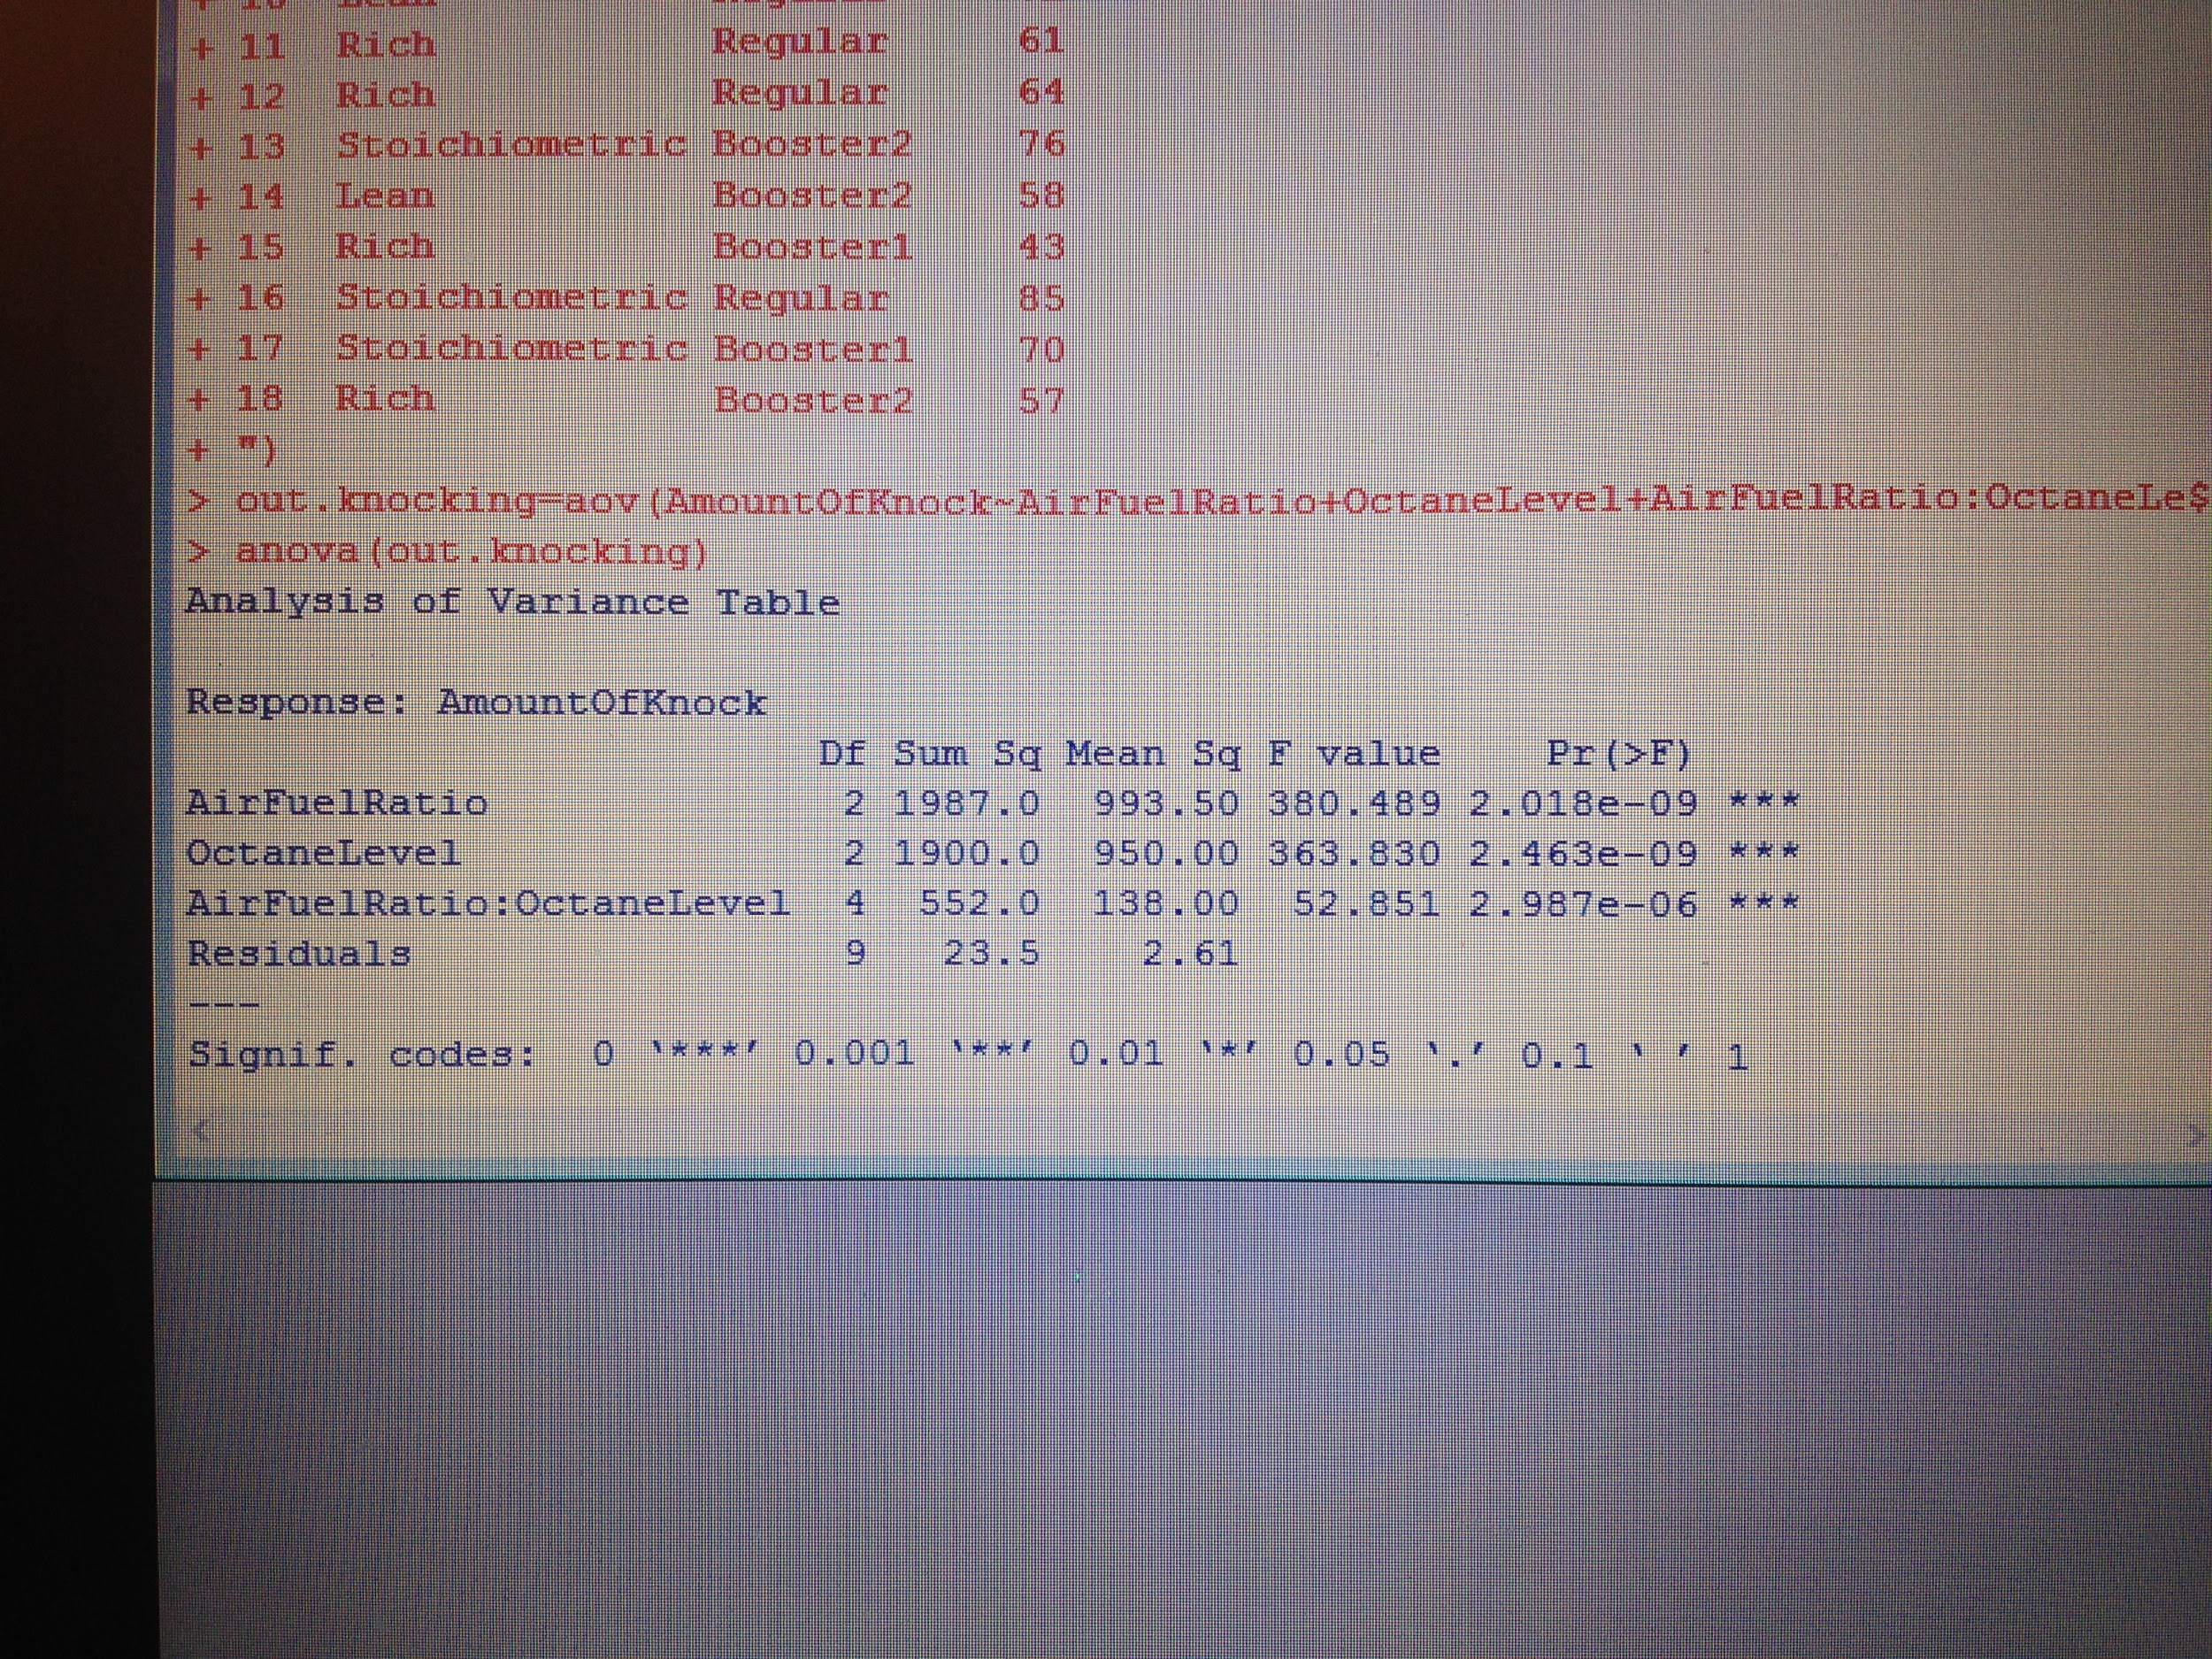

the p-values are all less than 0.05

